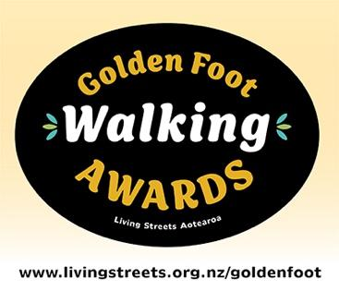
News release from Living Streets Aotearoa
23 July 2024
Winners of Golden Foot Walking Awards 2024 announced
The winners of the 2024 Golden Foot Walking Awards were announced tonight at an event at Parliament hosted by Celia Wade-Brown QSO MP.
These walking awards are presented every two years by Living Streets Aotearoa to celebrate achievements for walkers.
Living Streets Aotearoa president Tim Jones said the awards recognise innovative new facilities, highlight national best practice, and reward ongoing commitment to walking and pedestrians.
“We were delighted by the high standard of nominations for this year’s awards. It shows there is considerable thought going into projects that will support people walking to their everyday activities. This is very heartening to see,” he said.
This year there were 20 finalists with seven category winners.
A new special award was also presented, the Andy Smith Award, made in honour of a past-president of Living Streets. It was awarded to Wilderness Magazine for its Walk1200km initiative and accepted on the night by editor Alistair Hall. The initiative gained the highest score from the judges across all categories.

Winning project and nominee | Category | Description
Walk1200km  Wilderness Magazine | Andy Smith Award for exceptional achievement for walking  AND  Events Award Winner | Walk1200km is a challenge where participants attempt to walk 1200km in 12 months. The goal is to encourage and foster a daily walking habit. In the first year, approximately 2500 people joined, in the second it grew to around 4700, and in 2024 there are 6500 registered participants.
Waimataitai School Travel Plan, Waimataitai, Timaru  Waimataitai School | School Project Award | Waimataitai School committed to the development and implementation of a school travel plan to increase the use of active modes of transport, to improve safety, and reduce congestion at the school gate. At 12-month evaluation, walking and scooting have increased by 24%.
Frank Goldingham – A Lifelong Walking Champion  Frank Goldingham | Walking Champion Award Winner | Frank Goldingham has made a significant and lasting contribution to society via tirelessly championing walking in Aotearoa New Zealand and internationally. He has done this by promoting walking, profiling hundreds of walks, publicising walking events and walking groups throughout New Zealand through his magazine Walking New Zealand, and founding the successful Manawatū Walking Festival.
Geraldine Sculpture Trail  Geraldine.nz | Place-making Award Winner | The Geraldine Sculpture Trail was created to inspire and delight the community and visitors by developing four walking loops each connecting the CBD with the natural environment, art, history and  culture. Unique in New Zealand, this free and accessible open-air gallery showcases high quality art set in Geraldine’s riverside woodlands, Rhododendron Dell, expansive Domain and ancient podocarp forest.
Kiwi Seniors Active Walkers, Southland  Kiwi Seniors Active Walkers | Extraordinary Walkers Award Winner | The group started in 1992 as a Hillary Commission programme called Active in Age which was designed to encourage people aged over 50 to exercise more.  They have walked weekly since then and have a membership of more than 100. Walking is the main activity, but the social side is also very important.
Freyberg Street Neighbourhood Street Trial, Lyall Bay, Wellington  Wellington City Council | Urban Connection Award Winner | This is Wellington City Council’s first low traffic neighbourhood street trial. The goals of the project include enhancing safety for students commuting to Lyall Bay School, promoting the use of active transport modes among students and parents, and creating a more pleasant environment for people who live in the area and go to school there.
Urban Active Modes Plan  Far North District Council | Programmes Award Winner | Whilst the Far North District is largely rural, there are a dozen key urban areas where people could use active transport for many daily needs. These towns are generally compact, so the distance between destinations is suitable for walking. The urban active modes district-wide plan focuses on  improving footpaths and crossings in the district.

For more information contact:
Tim Jones President, Living Streets Aotearoa
tim.jones@livingstreets.org.nz
027 359 0293l
livingstreets.org.nz/goldenfoot

