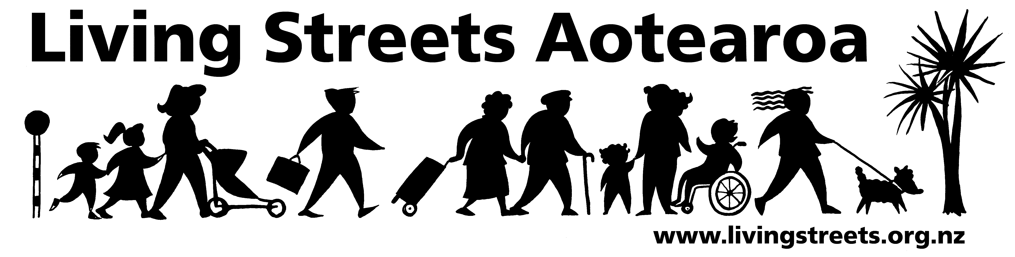

Submission from (local group name)
On xxxxxxxxxx

Organisation: (local group name)
Contact person:
Address:
Email:
Phone:
Date:

About Living Streets

Living Streets Aotearoa is New Zealand’s national walking and pedestrian organisation, providing a positive voice for people on foot and working to promote walking friendly planning and development around the country. Our vision is “More people choosing to walk more often and enjoying public places”.

The objectives of Living Streets Aotearoa are:
- to promote walking as a healthy, environmentally-friendly and universal means of transport and recreation
- to promote the social and economic benefits of pedestrian-friendly communities
- to work for improved access and conditions for walkers, pedestrians and runners e.g. walking surfaces, traffic flows, speed and safety
- to advocate for greater representation of pedestrian concerns in national, regional and urban land use and transport planning.

(name of local group) is the local walking action group based in the (region/area) which is working to make city and suburban centres in the region more walking-friendly.

For more information, please see: www.livingstreets.org.nz
Submission

